TheFacebook: Topic 2 Data Structure Project Report
WIA1002 Data Structure Group Assignment
Group Members:Dong Hanyu(20251960202), Chen Linkai(20251960250), Wang Jingyu(20251960115), Li Zhongwu(20251960283), Hu Shinuo(20251960203)

1. Project Introduction
TheFacebook is a Java-based social networking application developed for Topic 2 of the WIA1002 Data Structure group assignment. The project simulates an early social media platform where users can create accounts, log in, edit their profiles, search for other users, send and respond to friend requests, view mutual friends, receive friend recommendations, and generate a simple analysis report.
The main purpose of the project is to apply data structures in a meaningful software system. A social network is suitable for this topic because user accounts need efficient searching, friendships need graph representation, friend requests need organized processing, and session history can be represented using linked nodes.
The application was first built as a console program and later extended with a simple Java Swing graphical user interface. Both interfaces use the same service layer and data files, so the GUI does not replace the original logic. Instead, it provides a more user-friendly way to demonstrate the same functions.

2. Project Objectives
- To design a simple social media system using object-oriented programming.
- To apply suitable data structures such as graph, queue, stack, ArrayList, linked list, and custom hash table.
- To store user and friendship data permanently using CSV files.
- To implement the basic requirements of Topic 2, including registration, login, account editing, friend searching, mutual friends, friend requests, and mock data.
- To include extra features such as GUI, password hashing, data analysis, and enhanced networking.

3. System Overview
The system is organized into packages so that each part of the program has a clear responsibility. The model package stores data objects, the service package controls the business logic, the datastructures package stores self-built or selected data structures, and the ui package handles user interaction.
Class | Main Responsibility
Main | Loads data and starts either the GUI or the console interface.
User | Stores user profile information, password hash, hobbies, career history, and role.
Role | Defines USER and ADMIN roles.
FriendRequest | Represents one friend request from one user to another user.
SocialNetwork | Controls core functions such as login, registration, search, friend requests, recommendations, mutual friends, reporting, and deletion.
CsvStorage | Handles reading and writing users, friendships, requests, and reports.
PasswordUtil | Hashes passwords using SHA-256.
MyHashTable | Custom generic hash table used for fast lookup.
FriendGraph | Stores friendships and performs graph-related operations.
BrowsingHistory | Stores current session actions using linked nodes.
ConsoleUI | Provides the original menu-based console interface.
TheFacebookGUI | Provides the simple Swing graphical interface.

4. Basic Features and Implementation Methods

4.1 Data Storage
The program stores data in CSV files inside the data folder. users.csv stores account information, friendships.csv stores friendship edges, and requests.csv stores pending friend requests. CsvStorage uses file reading and writing to make sure data remains after the program closes.

4.2 Login, Registration, and Account Setup
The register method in SocialNetwork checks password confirmation, email or phone format, and duplicate username, email, or phone number. Passwords are hashed before storage. The login method searches by email first, then by phone number, and compares the hashed password.

4.3 Edit Account
Users can edit profile fields such as name, birthday, address, gender, relationship status, hobbies, and career history. Hobbies are stored in an ArrayList because the list can grow dynamically. Career history is stored in a Stack so the newest record can be shown first.

4.4 Add New Friends
A user can send a friend request to another user. Pending requests are stored in a Queue because requests can be reviewed in first-in-first-out order. When a request is accepted, FriendGraph adds an undirected friendship edge between the two users.

4.5 User Access Control
The Role enum separates USER and ADMIN accounts. Admin users can access the delete user function. This demonstrates basic access control using object-oriented programming.

4.6 Search for Friends
Users can search by name, username, ID, email, or contact number. Search results are placed in an ArrayList and sorted by name before being displayed.

4.7 View Account
The publicProfile method in User formats important profile information, including name, username, gender, age, address, relationship status, hobbies, career history, friend count, and role.

4.8 Mutual Friends
Mutual friends are found by getting the friend lists of two users from the graph and comparing them. If the same user ID appears in both lists, that user is a mutual friend.

4.9 Traceback Function
BrowsingHistory uses self-defined linked nodes. Each node stores one action and links to the previous and next action. The history is only for the current session and is cleared after logout.

4.10 Mock Data
The data files contain 30 normal users and 2 admin users. This allows the system to be tested without manually registering many accounts.

5. Data Structures Used
Data Structure | Used In | Reason for Selection
Custom Hash Table | usersById, usersByEmail, usersByPhone, usersByUsername | Provides fast lookup and avoids direct use of java.util.HashMap.
Graph | FriendGraph | Friendship connections are naturally represented as users connected by edges.
Queue | Friend requests | Friend requests can be handled in first-in-first-out order.
ArrayList | Search results, friends, hobbies, recommendations | Suitable for dynamic lists that are often traversed and displayed.
Stack | Career history | The newest career or study record can be pushed and shown first.
Linked List | BrowsingHistory | Stores session actions and allows moving back through previous actions.

6. Extra Features
Extra Feature | Implementation Details
Graphical User Interface | TheFacebookGUI.java uses Java Swing components such as JFrame, JPanel, JButton, JTextField, JPasswordField, JOptionPane, JScrollPane, and JTextArea.
Password Hashing | PasswordUtil uses SHA-256 so passwords are not stored in plaintext.
Data Analysis | SocialNetwork can generate analysis_report.txt with total accounts, admins, normal users, friendship count, pending requests, average age, and gender count.
Enhanced Networking | FriendGraph uses BFS to calculate connection degree up to the third degree and support friend recommendations.

7. Member Roles and Contributions
The following table divides the work among five members. The member names can be replaced with the actual names before submission. Each class is assigned to the member who is mainly responsible for writing and explaining it.
Member | Main Role | Classes / Files Completed | Detailed Contribution
Member 1  Name: Dong hanyu  (20251960202) | Project leader and core service developer | SocialNetwork.java,  ConsoleUI.java, | Designed the program flow, connected storage and UI layers, implemented registration, login, update profile, search, friend request handling, mutual friends, recommendations, admin deletion, report generation, and mock data loading.
Member 2  Name:Chen Linkai  (20251960250) | Data model developer | User.java, Role.java, FriendRequest.java | Created the user account object, role enum, friend request object, CSV conversion methods, age calculation, public profile display, hobbies ArrayList, and career Stack.
Member 3  Name:Wang Jingyu  (20251960115) | Data structure developer | MyHashTable.java, FriendGraph.java, BrowsingHistory.java | Implemented the custom generic hash table, adjacency-list graph, BFS connection degree, mutual friend logic, recommendation sorting, and linked-list traceback history.
Member 4  Name:Li Zhongwu  (20251960283) | Storage and security developer | CsvStorage.java, PasswordUtil.java, data/*.csv | Implemented CSV reading and writing, report file output, data folder management, SHA-256 password hashing, and prepared or checked mock data files.
Member 5  Name:Hu Shinuo  (20251960203) | User interface and testing developer | Main.java, TheFacebookGUI.java | Built the menu-based console interface, added the simple Swing GUI, connected buttons and dialogs to the SocialNetwork methods, tested main user flows, and prepared screenshot evidence.

8. Problems Faced and Solutions
Problem | Solution
Direct use of HashMap was not allowed by the assignment. | A custom generic MyHashTable class was implemented using buckets and linked entries. It supports put, get, remove, keys, values, clear, and resize.
Friend relationships are difficult to manage using only arrays or lists. | A graph was used. Each user is a node and each friendship is an undirected edge. This makes mutual friends and connection degree easier to implement.
Data should not disappear after the program closes. | CsvStorage was created to save users, friendships, and requests into CSV files, then load them again when the program starts.
Passwords should not be stored as plaintext. | PasswordUtil hashes passwords with SHA-256 before saving them to users.csv.
The console interface was not attractive enough as a social media application. | A simple Swing GUI was added. It uses basic components so it is easy to understand and suitable for a first-year project.
The GUI and console could have duplicated the same logic. | Both interfaces call the same SocialNetwork methods, so the business logic remains in one place.
Friend recommendations need to consider indirect connections. | Breadth-first search is used in FriendGraph to explore up to third-degree connections.
The program needed enough test users. | The seed data and CSV files contain 30 normal users and 2 admins, satisfying the mock data requirement.

9. Program Screenshots
Please insert the actual screenshots into the blank boxes below before final submission. Each screenshot should show the full application window clearly.

Screenshot 1: GUI Start Pag
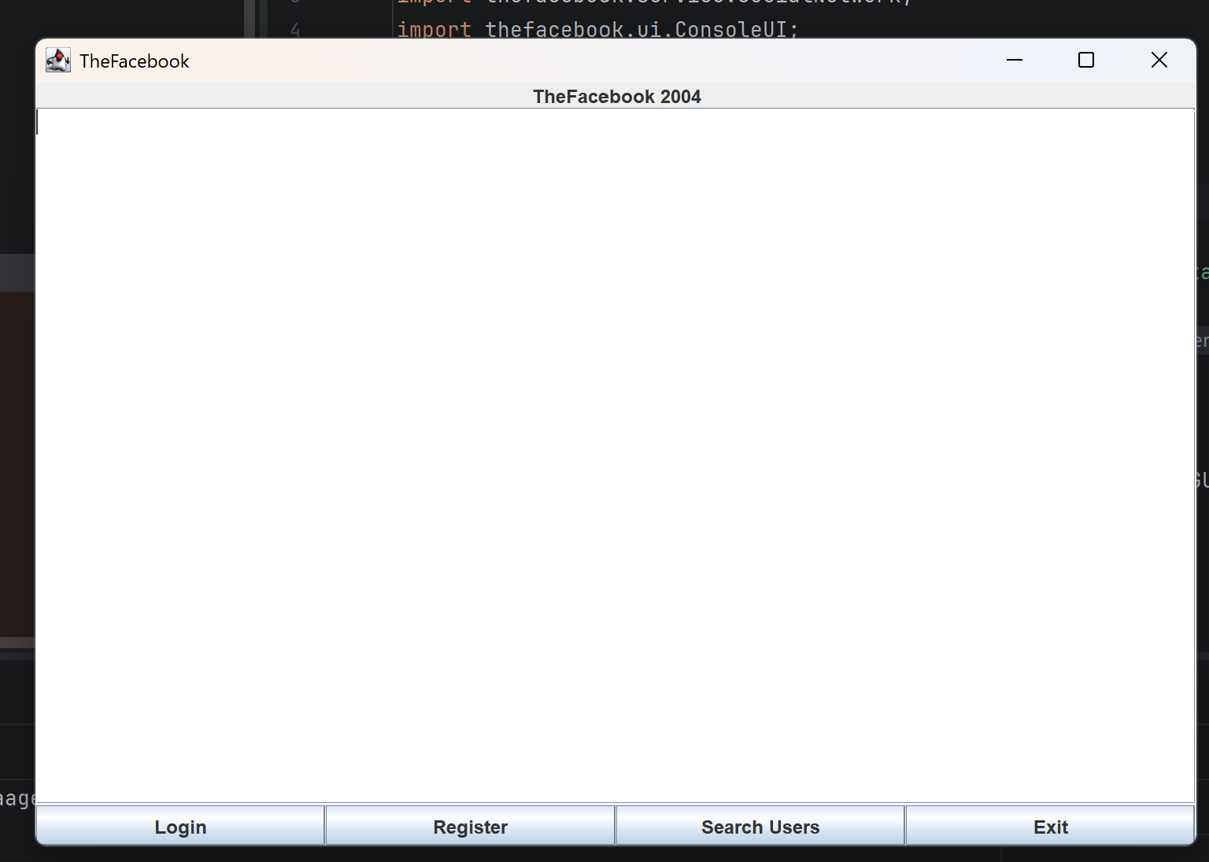

Screenshot 2: Login Dialog
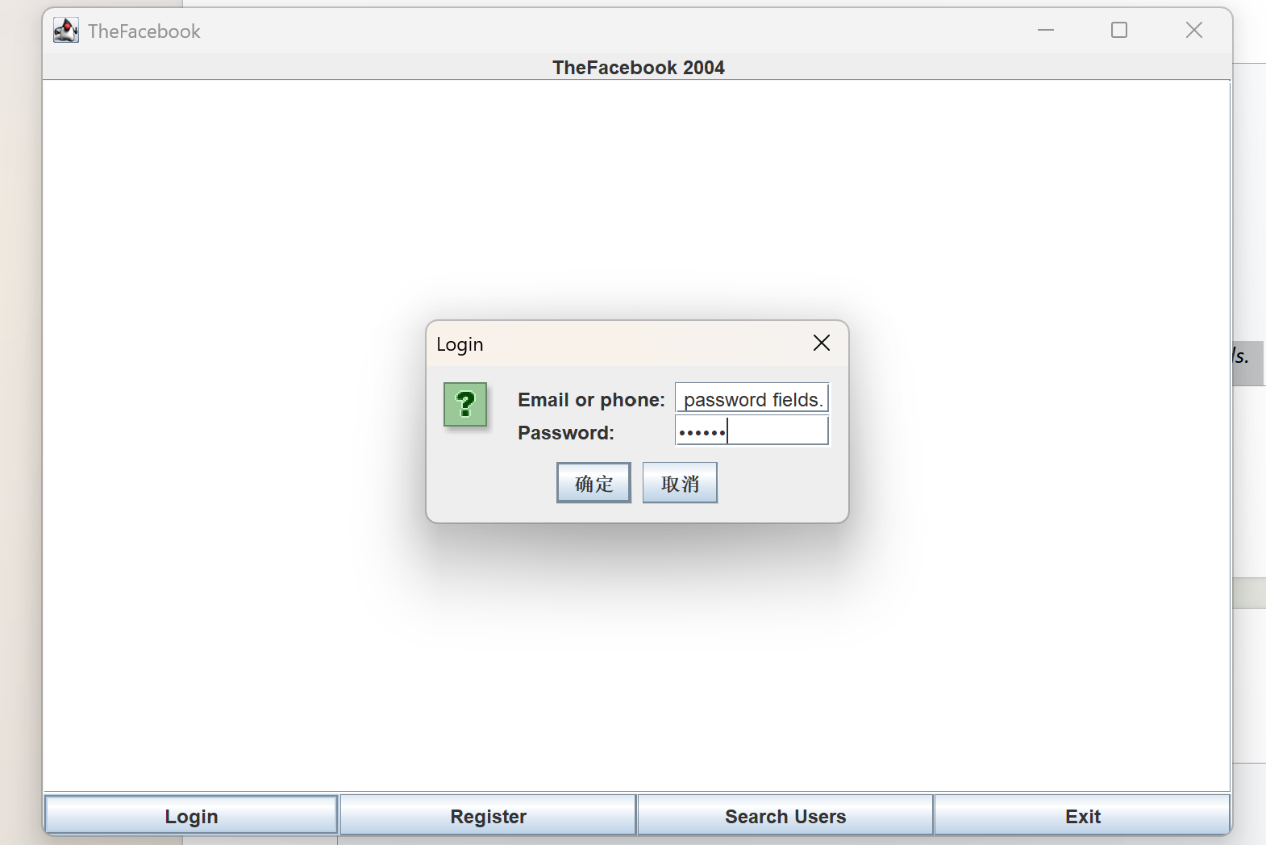

Screenshot 3: User Home Page
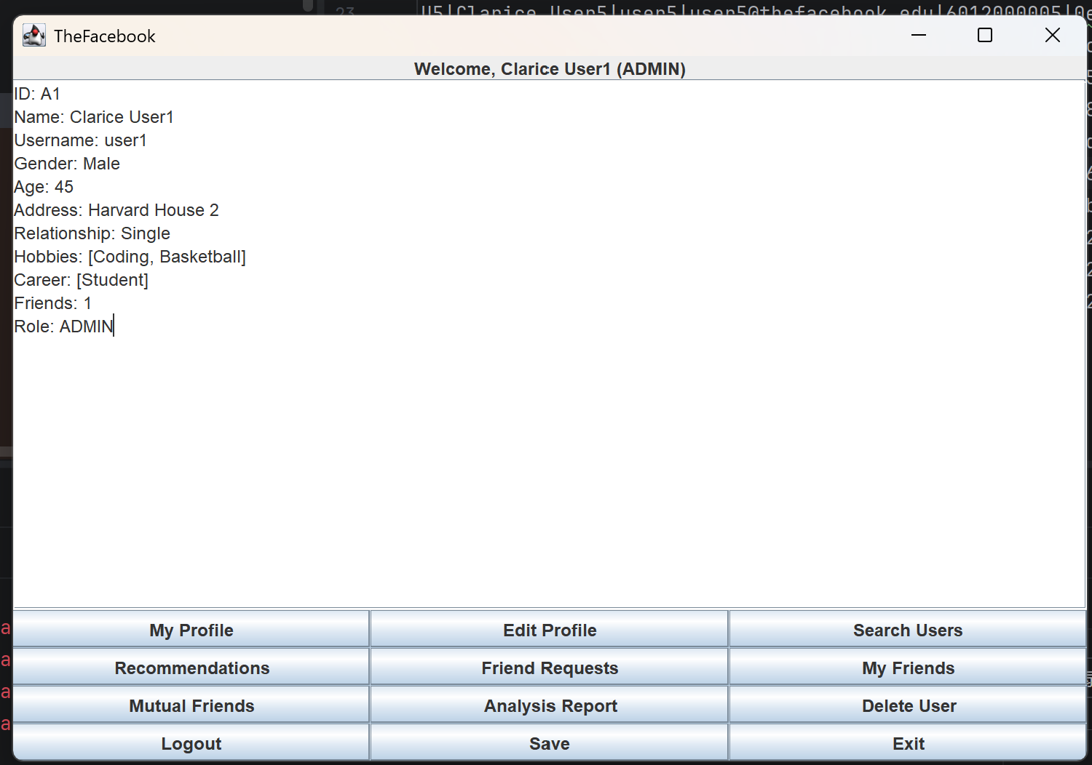

Screenshot 4: Register Function
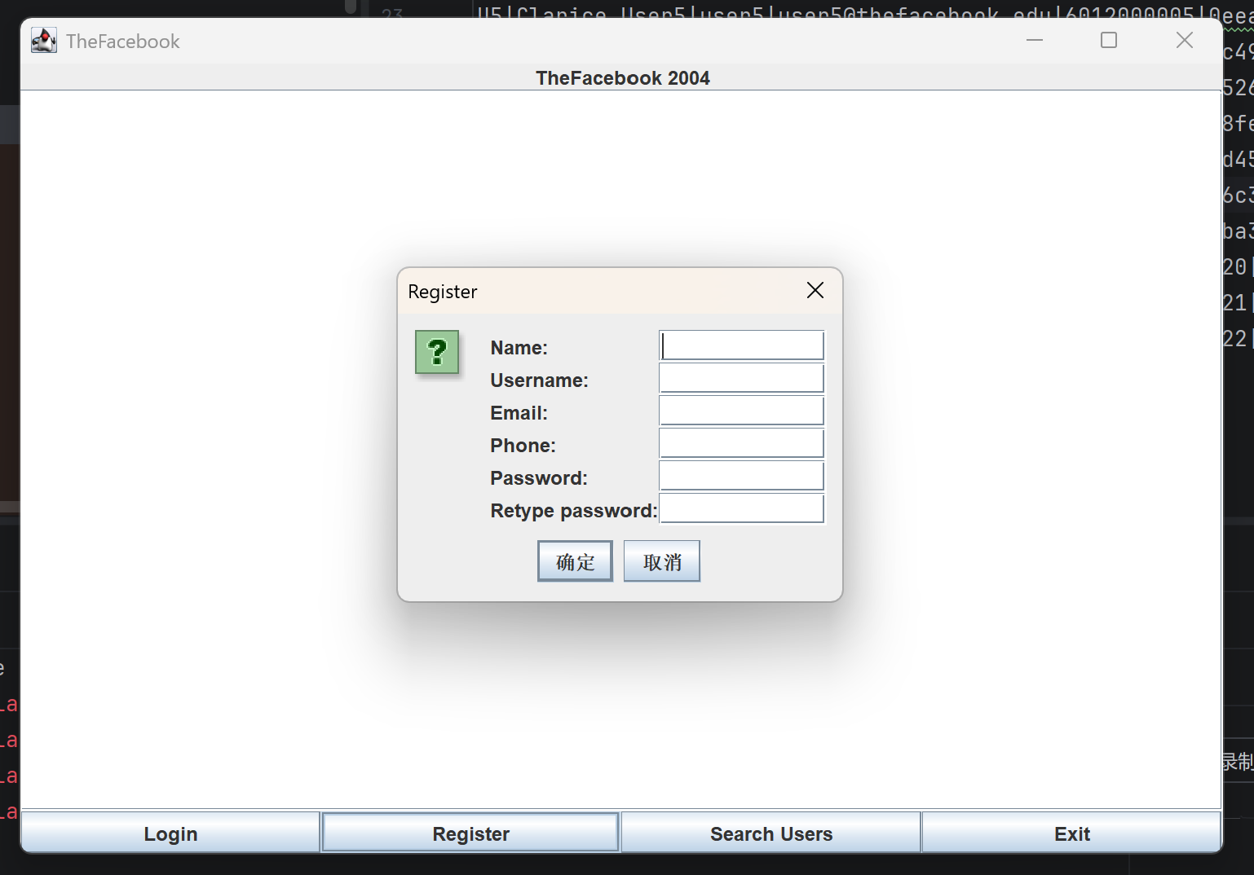

Screenshot 5: Search Users Function
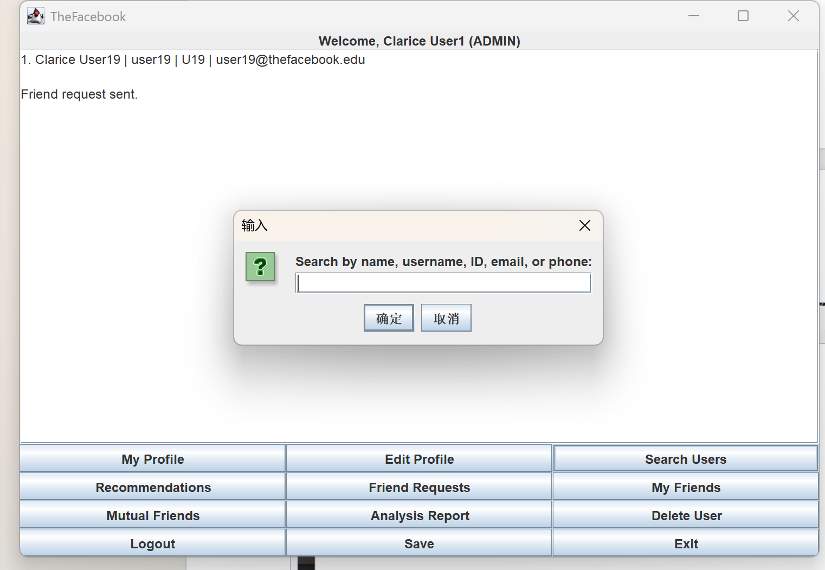

Screenshot 6: Friend Recommendations
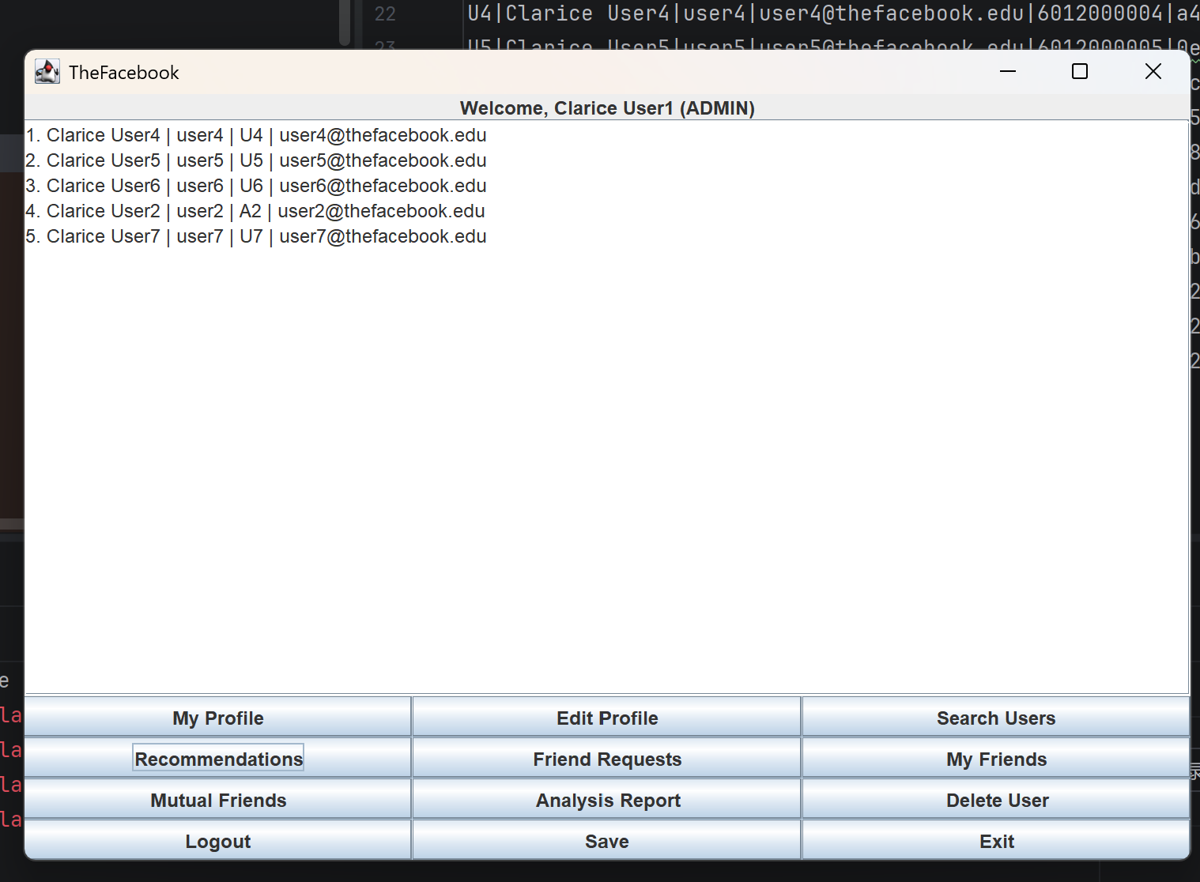

Screenshot 7: Friend Requests
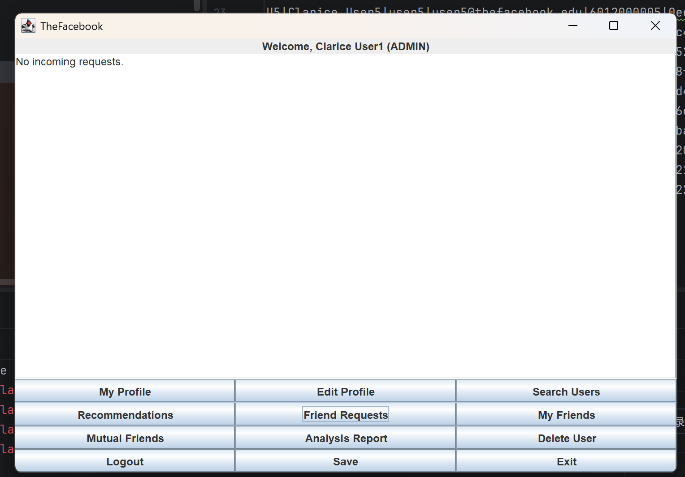

Screenshot 8: Mutual Friends
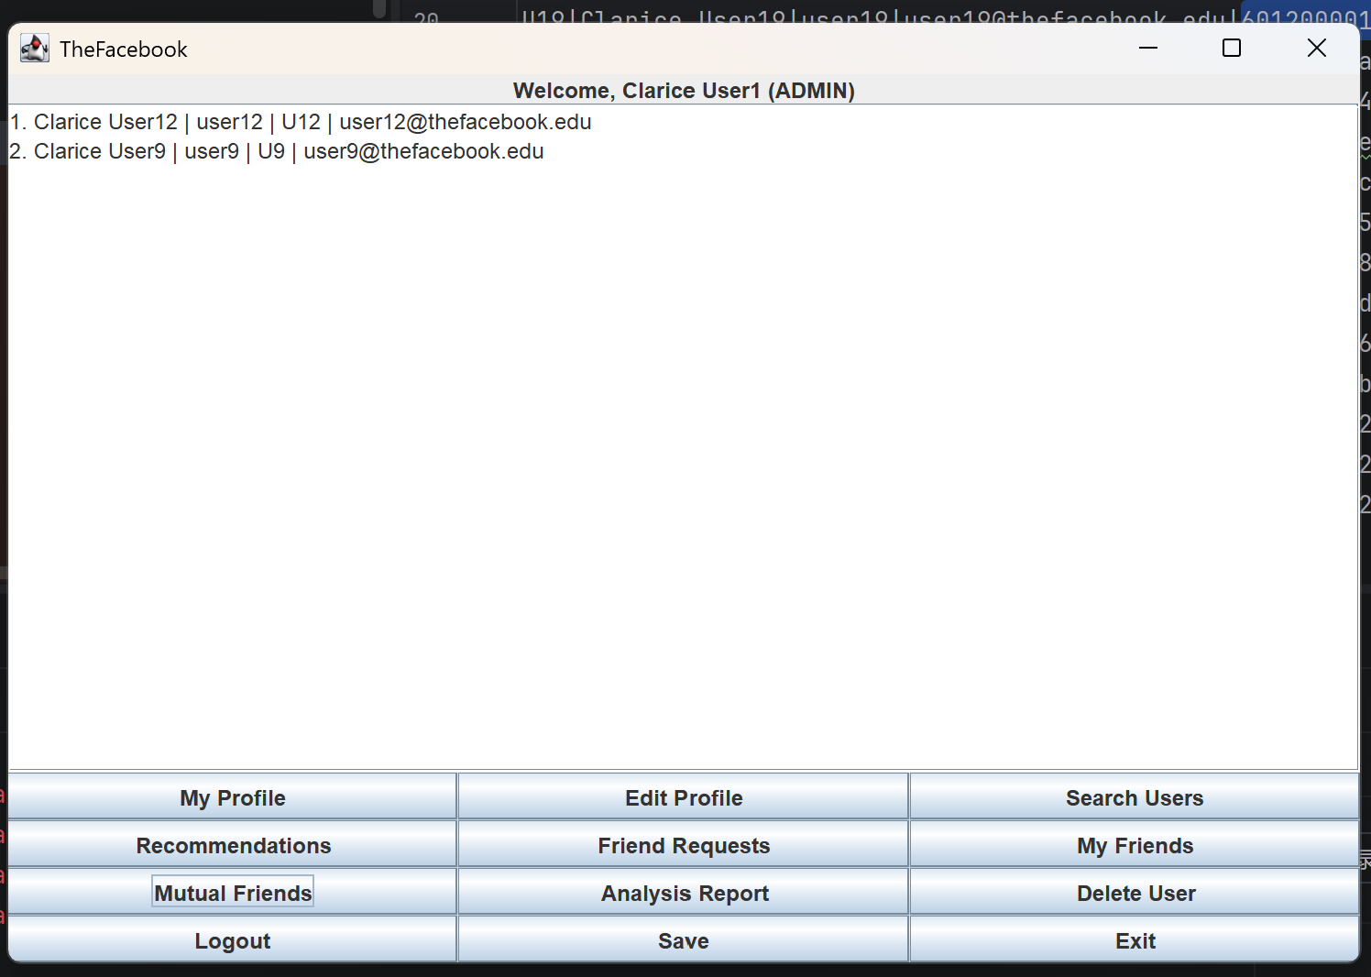

Screenshot 9: Admin Delete User
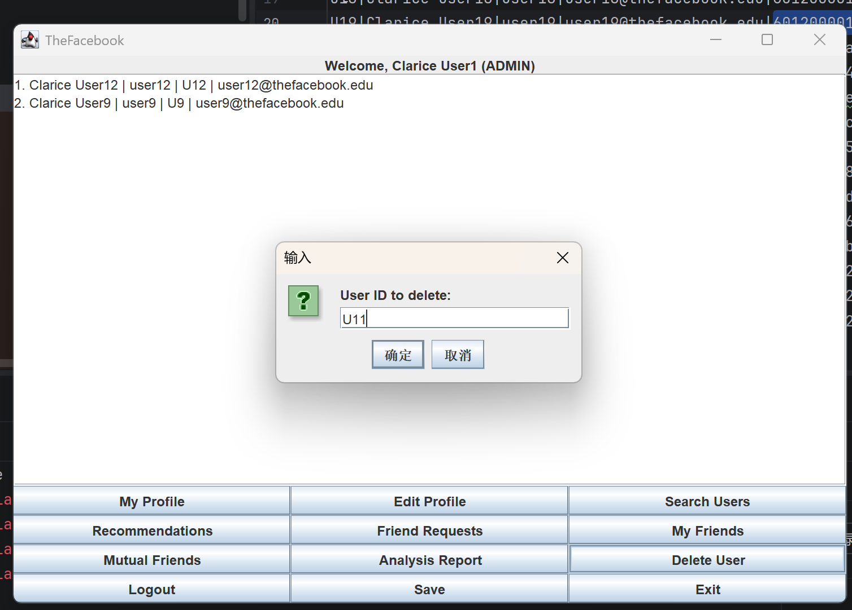

Screenshot 10: Data Analysis Report
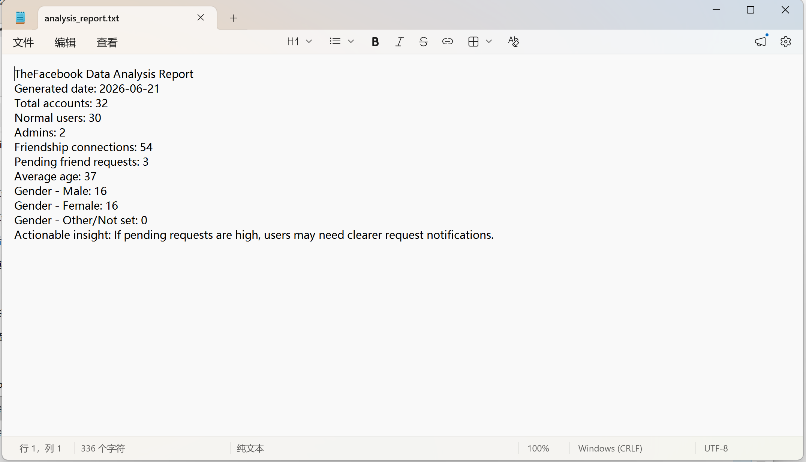

10. Testing Summary
- The Java source files were compiled successfully using javac.
- The console version was tested by running the program with the console argument.
- The GUI version was tested by opening the Swing window and checking the main buttons and dialogs.
- The data folder was checked and contains 32 mock users: 30 normal users and 2 admin users.
- The same CSV files are used by both the console version and the GUI version.

11. Limitations and Future Improvements
- The GUI is intentionally simple. It can be improved with tables, better layout, and profile pictures.
- The traceback function stores session actions but can be improved to reopen the exact previous profile or content page.
- Editing username, email, or phone number can be improved with duplicate checking.
- Future features can include groups, chat, fuzzy search, privacy settings, and a real database such as MySQL.

12. Conclusion
TheFacebook demonstrates how data structures can support a social networking application. The project uses a custom hash table for fast user lookup, a graph for friendship relationships, a queue for friend requests, an ArrayList for dynamic collections, a stack for career history, and linked nodes for traceback history. The simple Swing GUI improves usability and supports the extra feature requirement. Overall, the program covers the major basic requirements of Topic 2 and includes meaningful extra features that can be explained clearly during presentation.

